

ACA Module 13 Challenge Lab

____________________________________________________

COS 20019- Cloud Computing Architecture

Nguyen Manh Dung

5/7/2023

**Task 1: Downloading the source code**

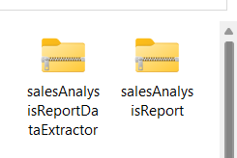

**Answering questions about the lab**

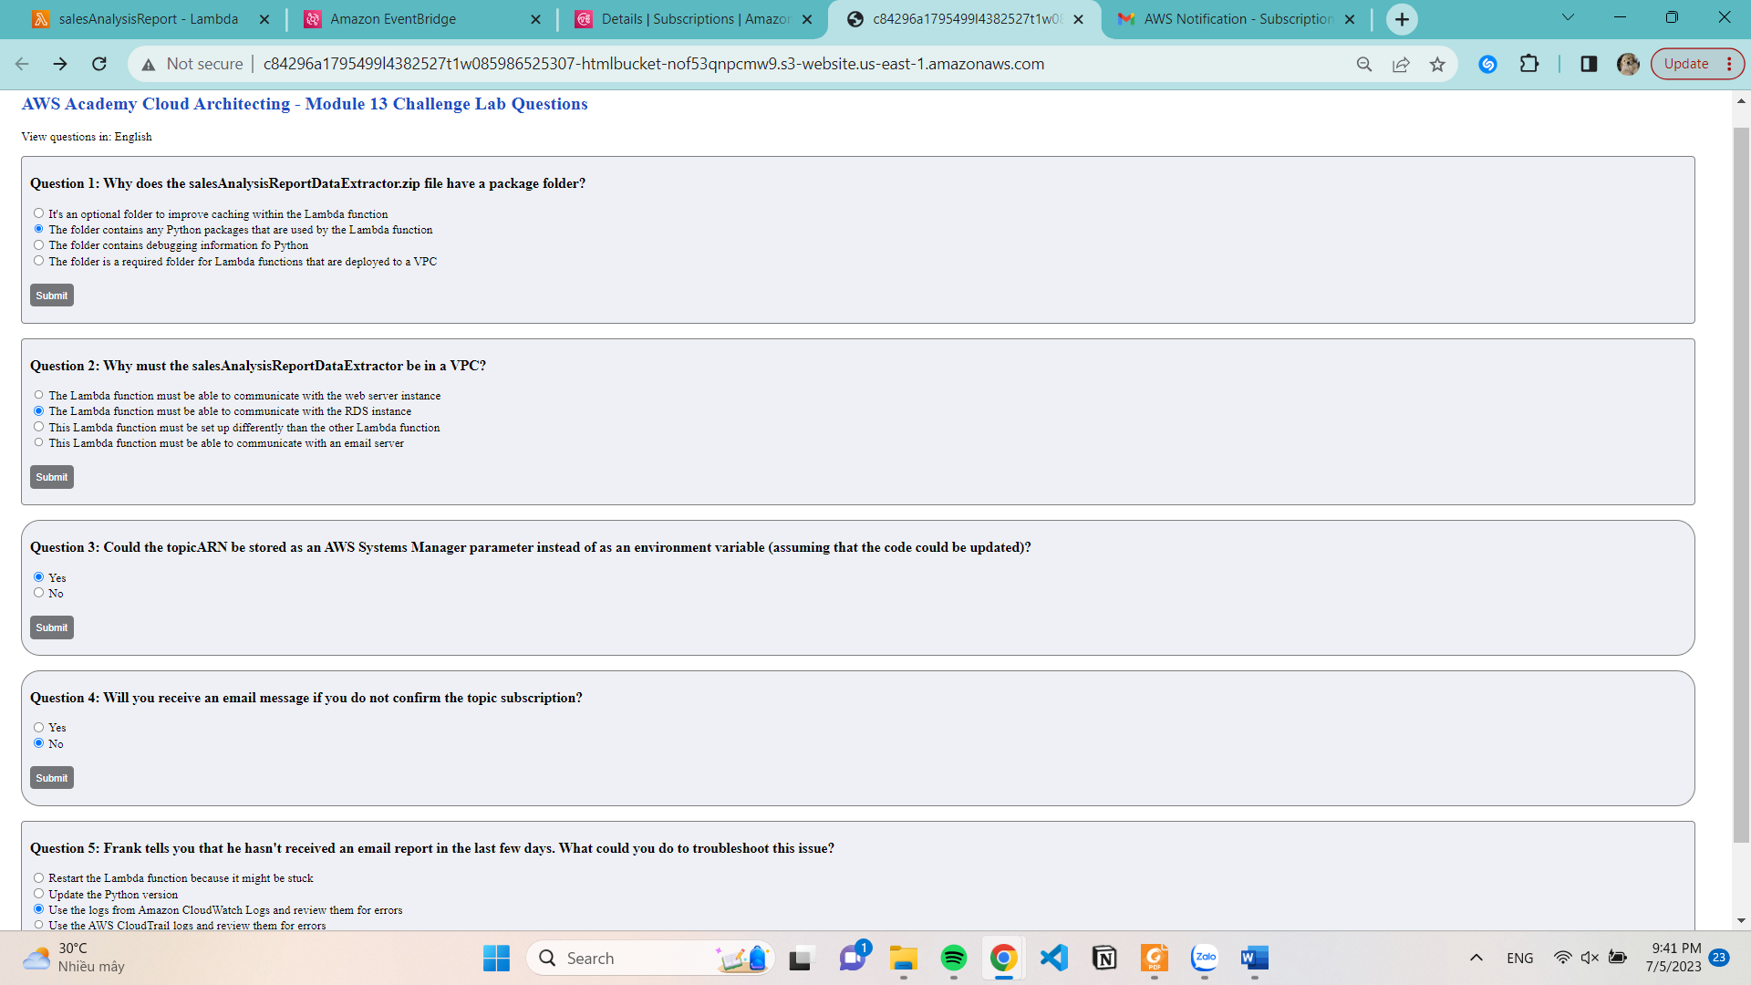

**Task 2: Creating the DataExtractor Lambda function in the VPC**

**Create Security Group**

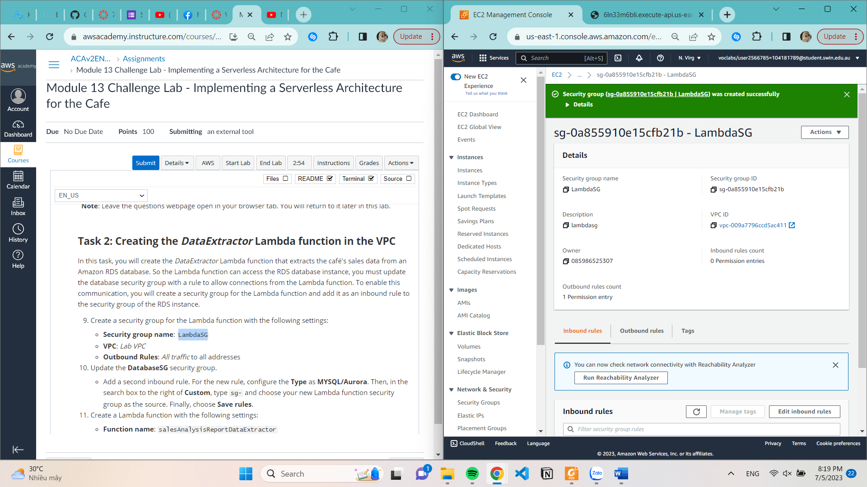

**Update the DatabaseSG security group.**

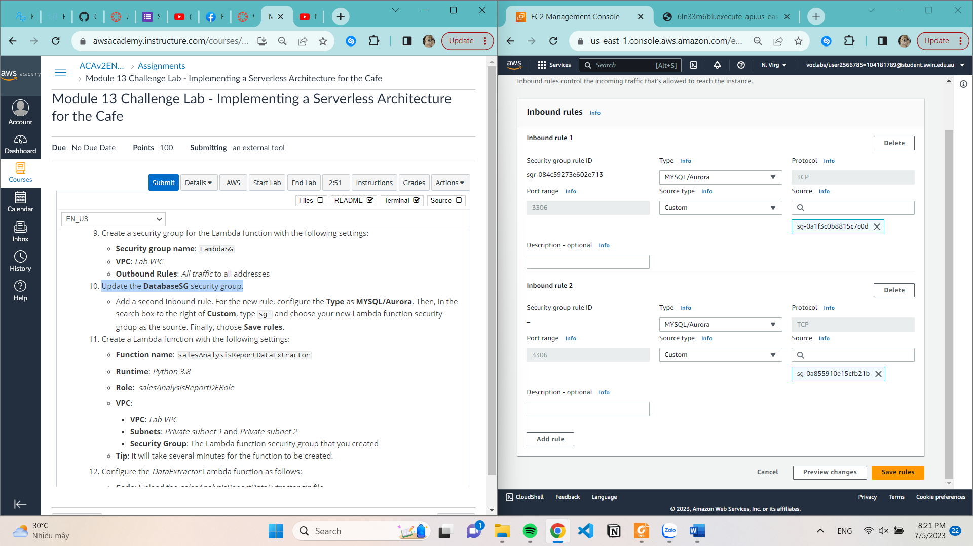

**Create a Lambda function**

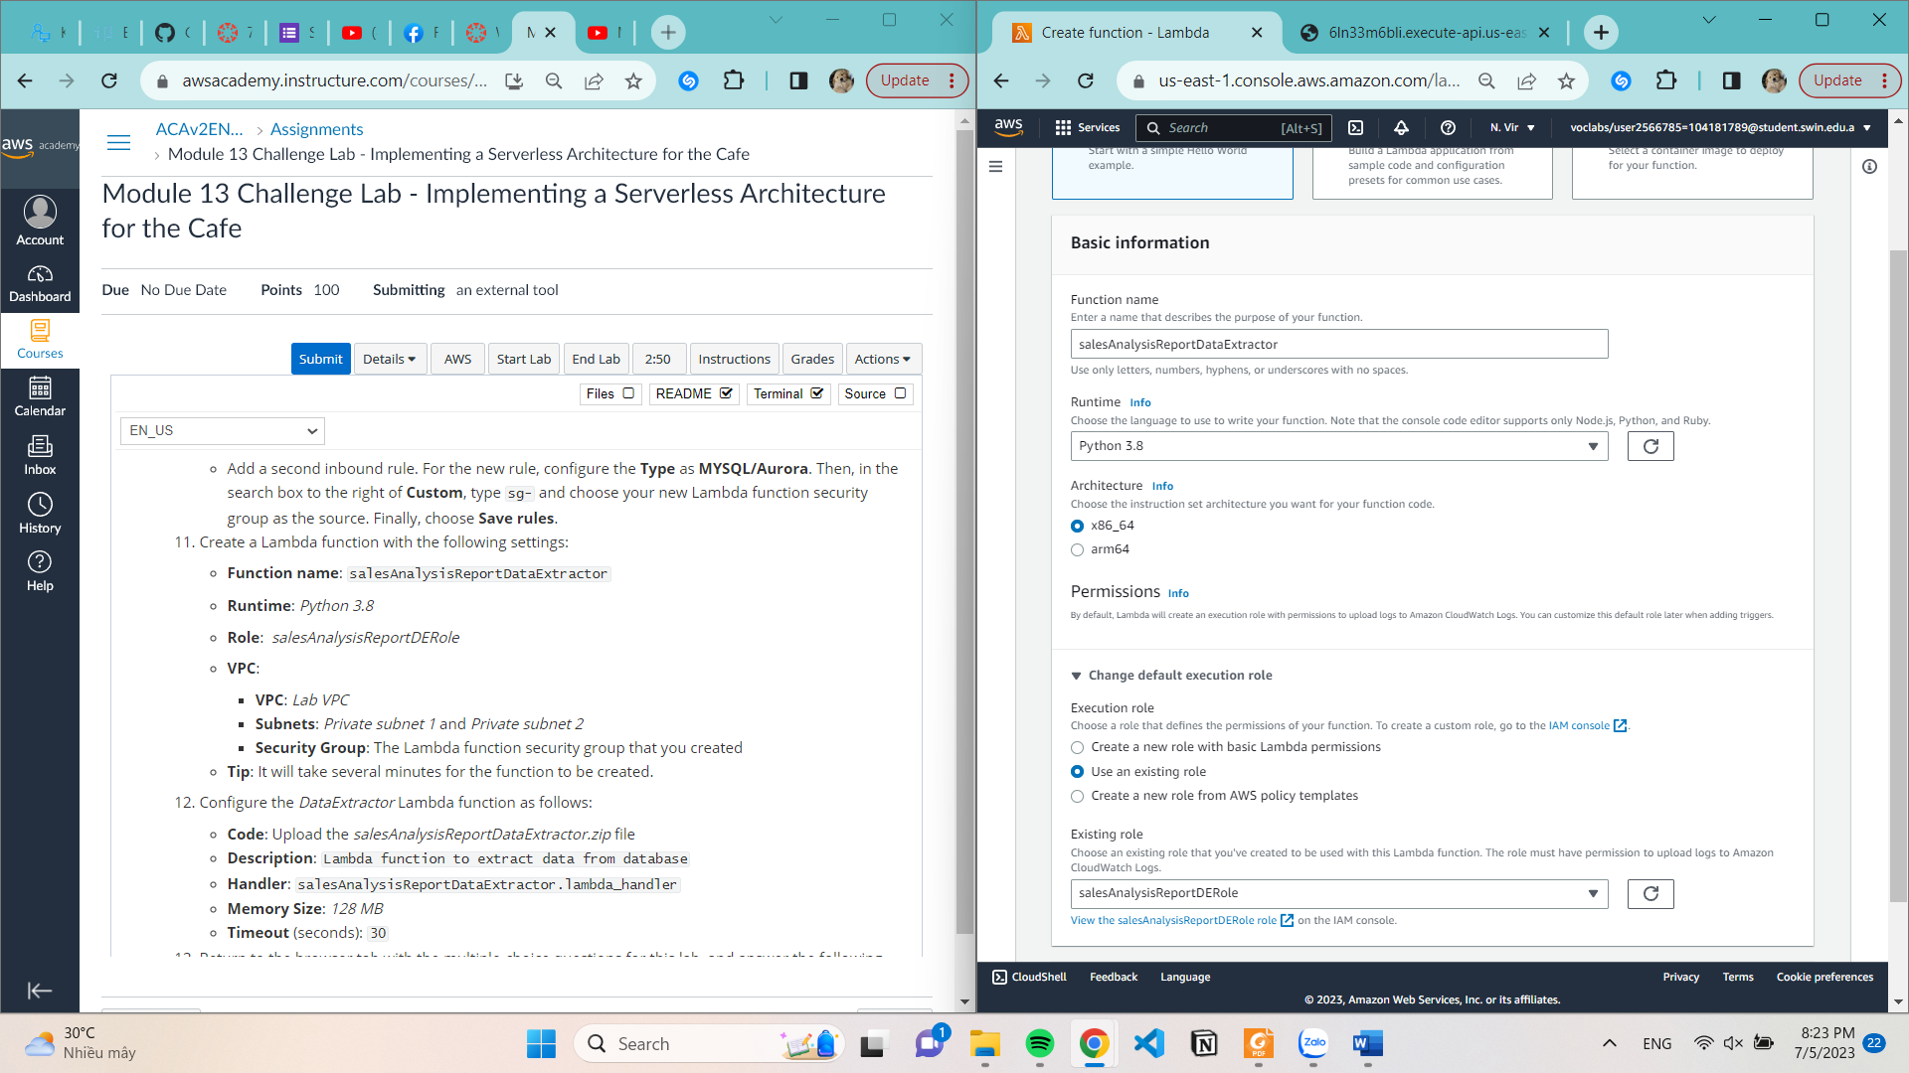

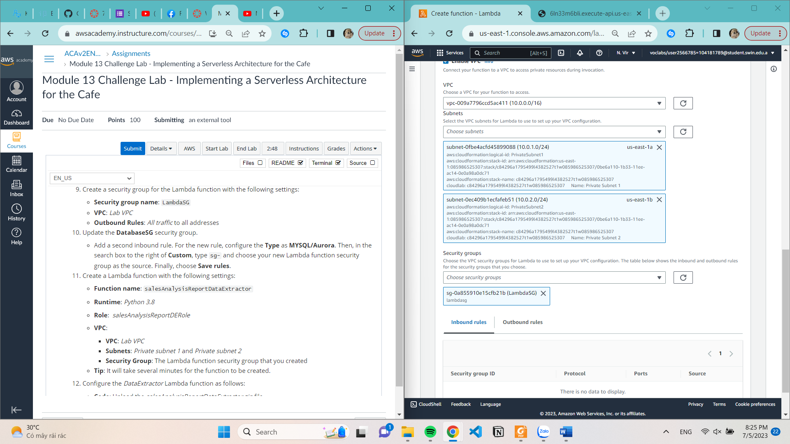

**Upload code**

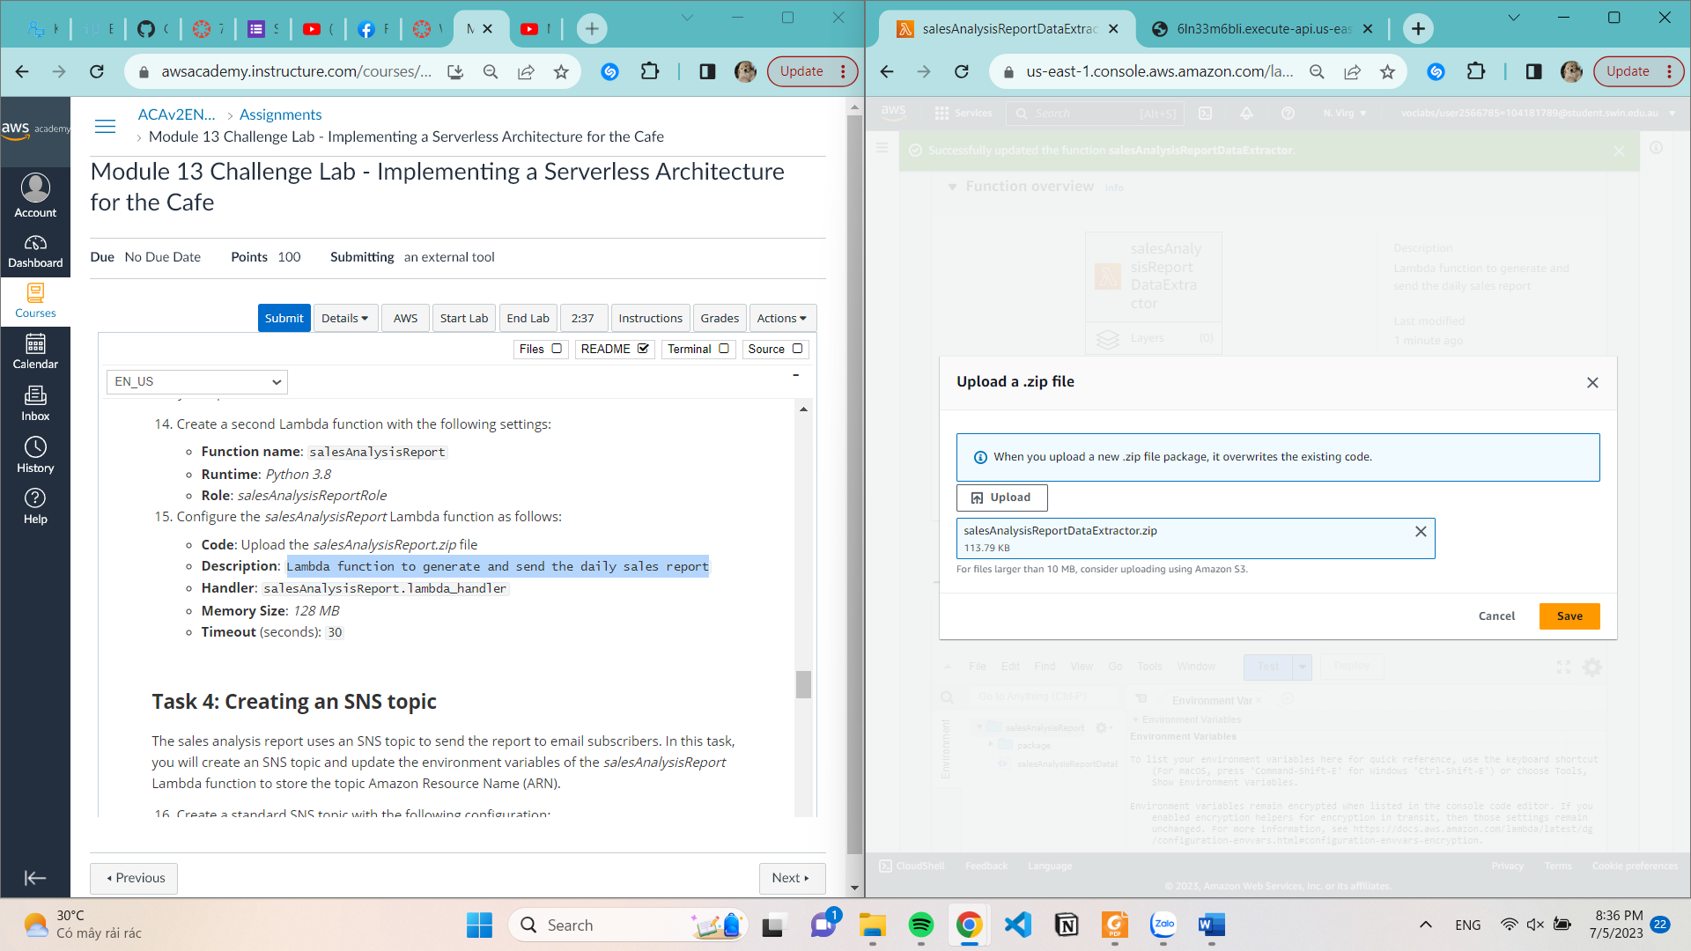

**Configure Description**

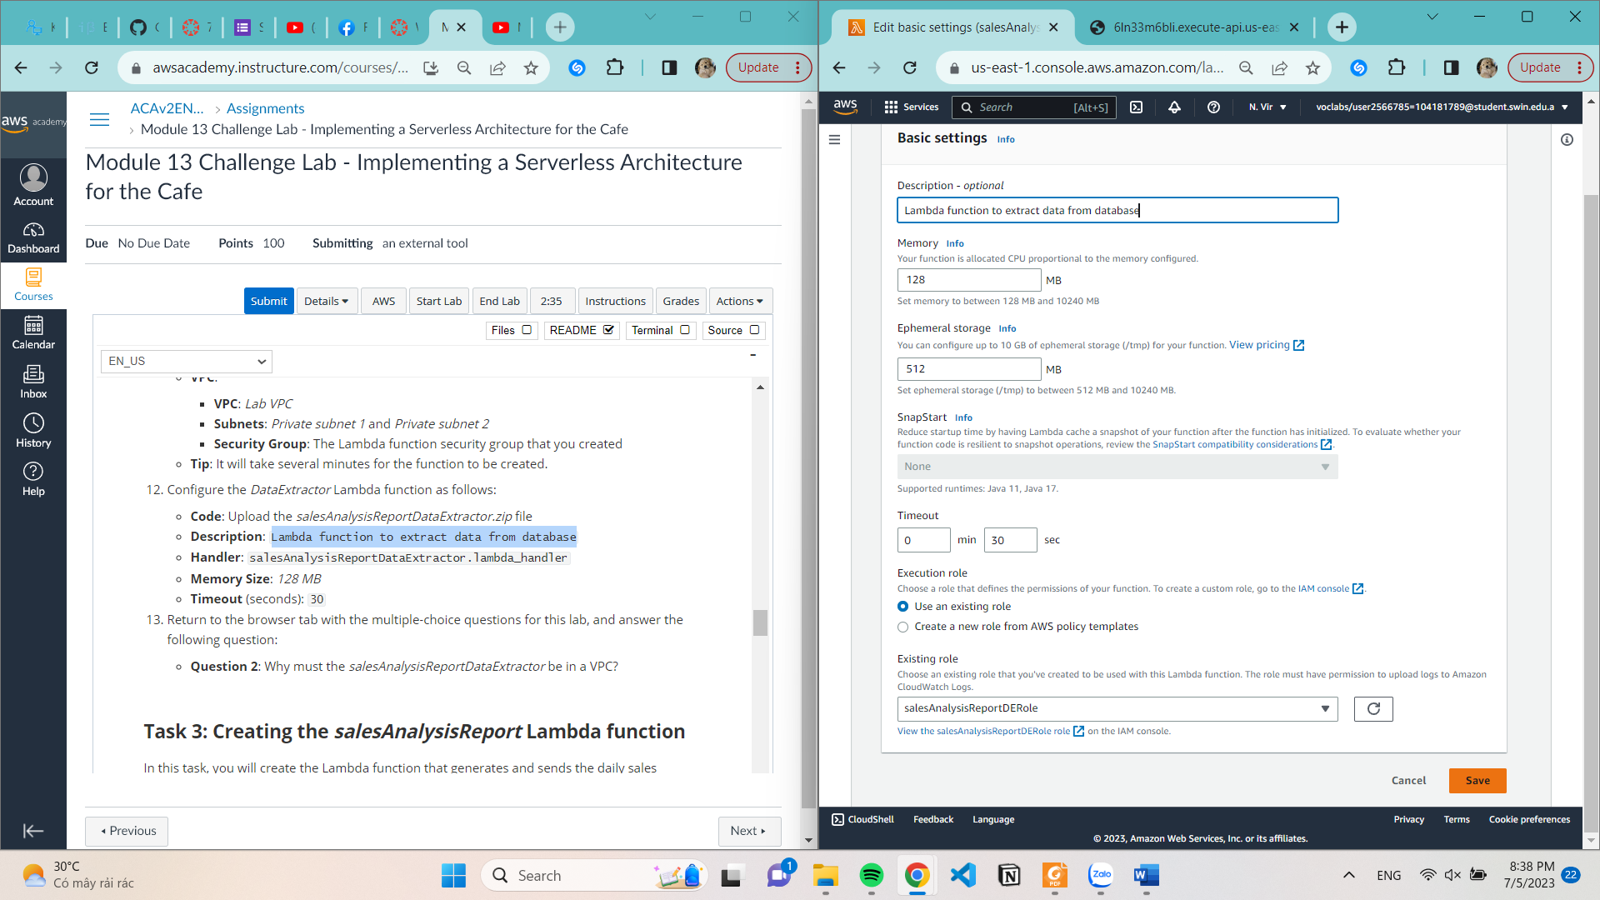

**Edit Handler**

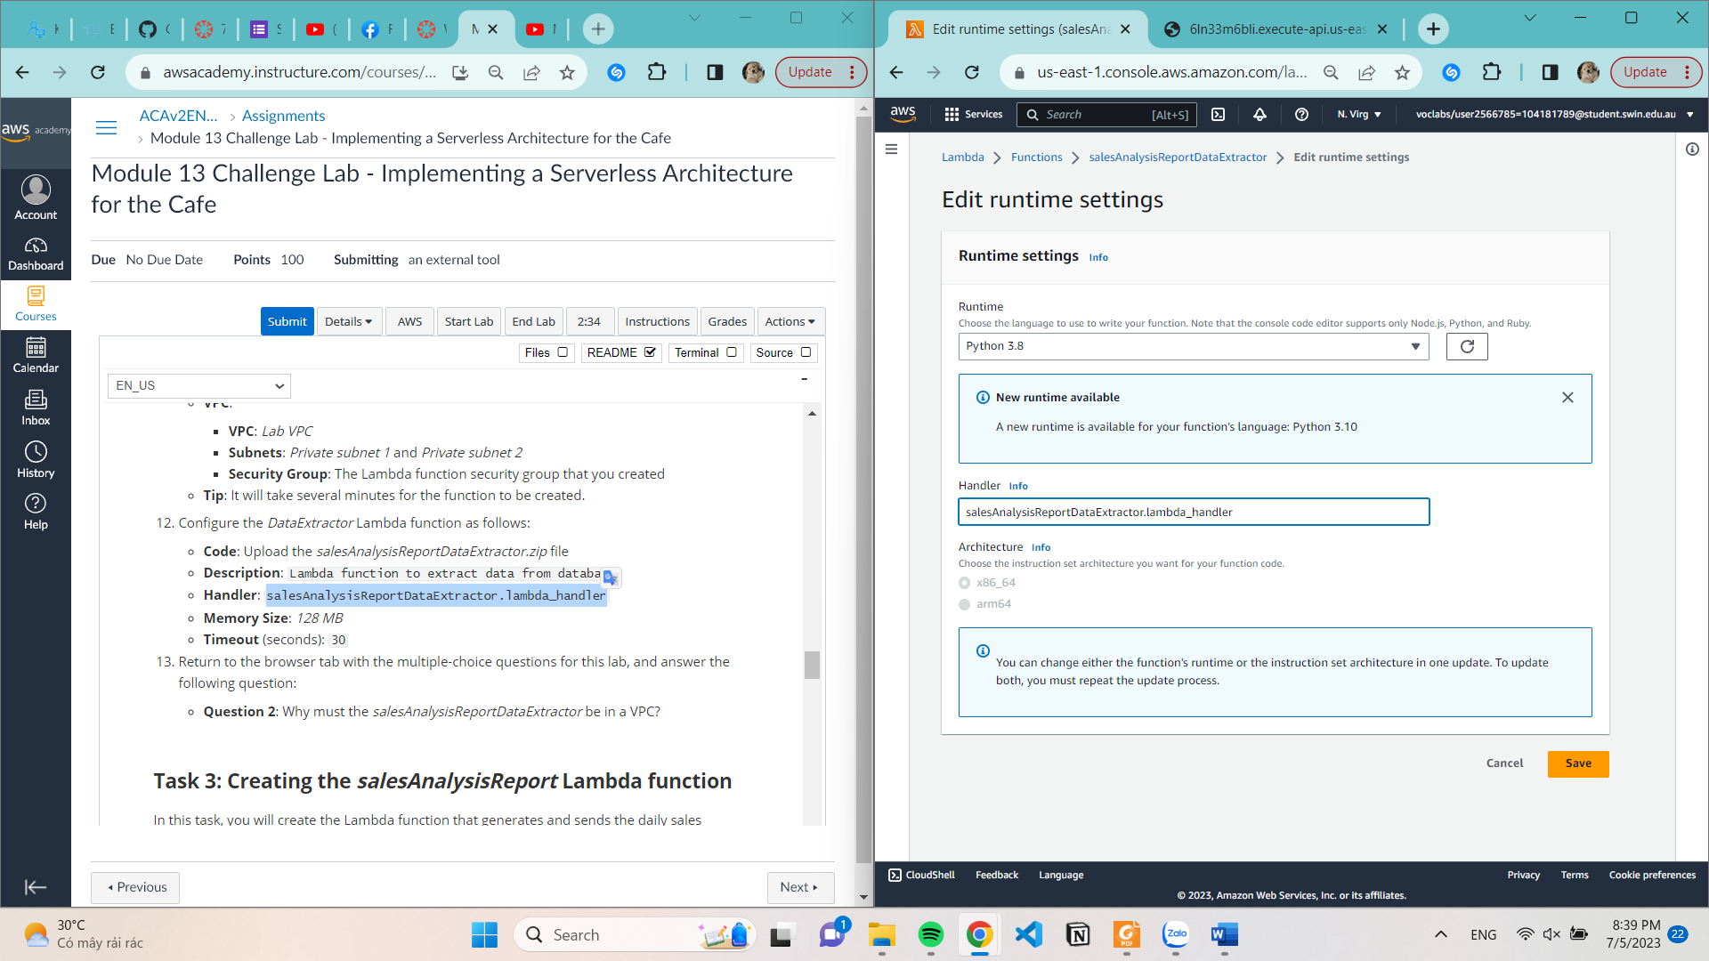

**Task 3: Creating the salesAnalysisReport Lambda function**

**Create a second Lambda function**

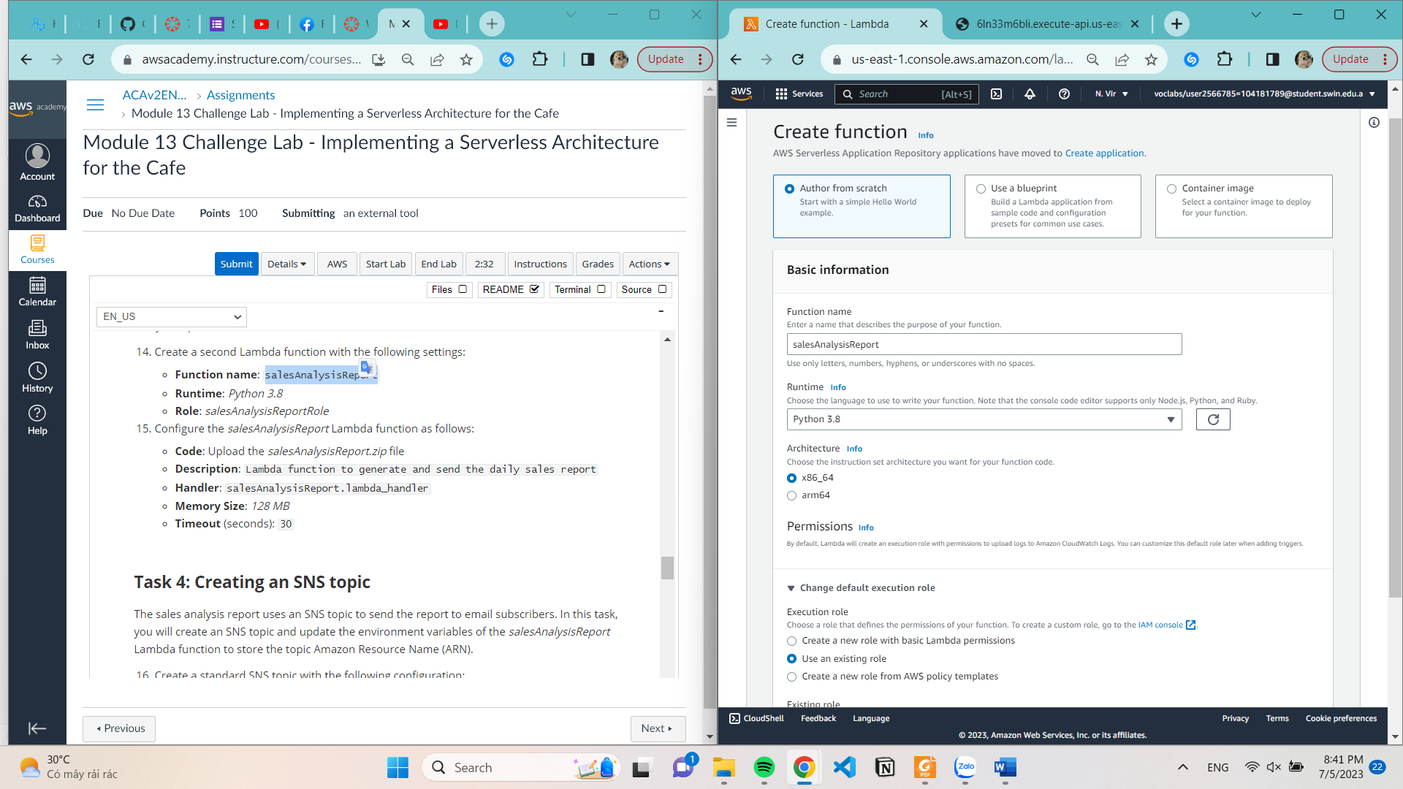

**Upload code**

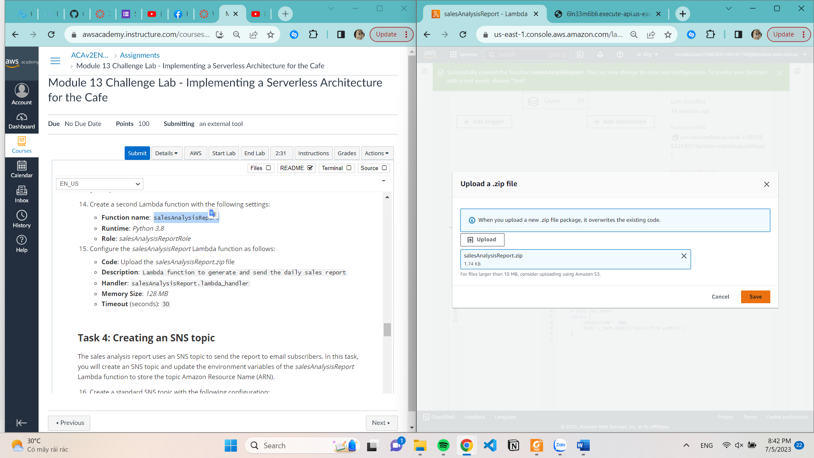

**Configure Description and Timeout**

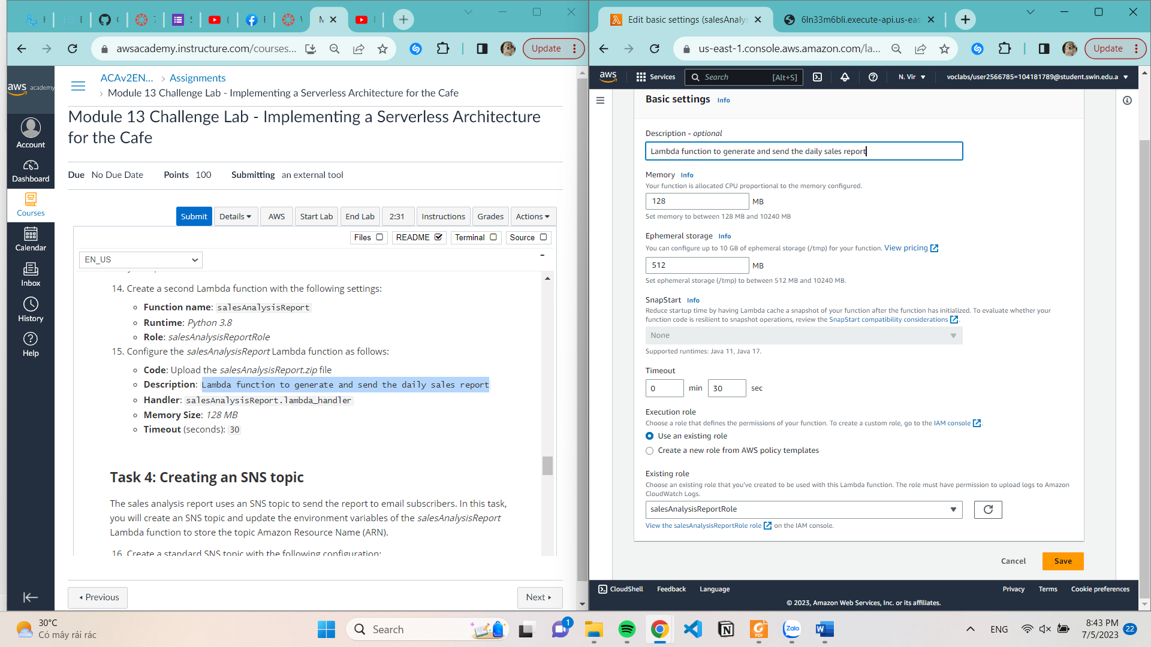

**Edit Handler**

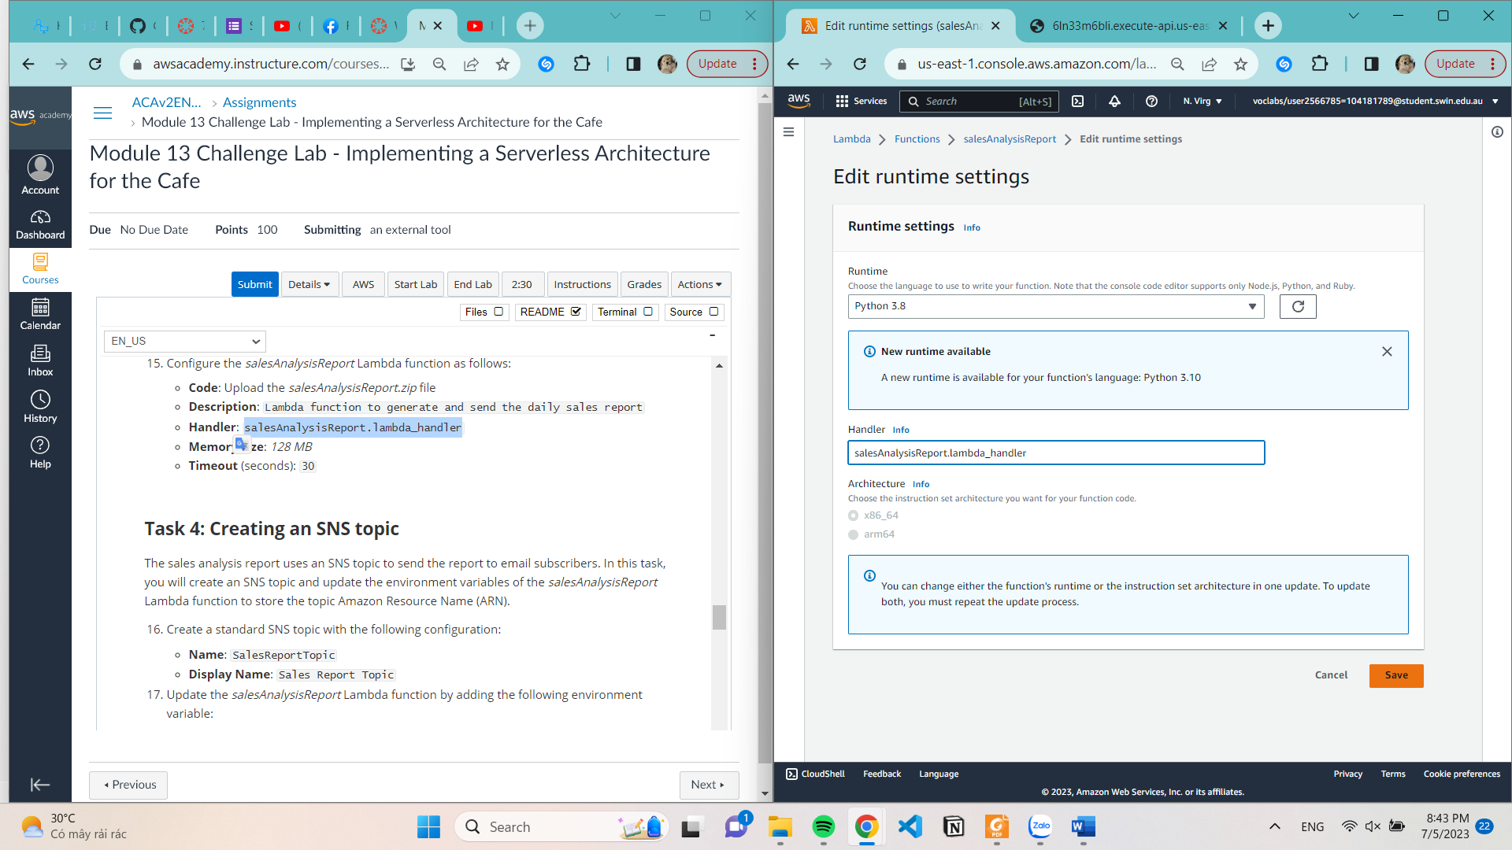

**Task 4: Creating an SNS topic**

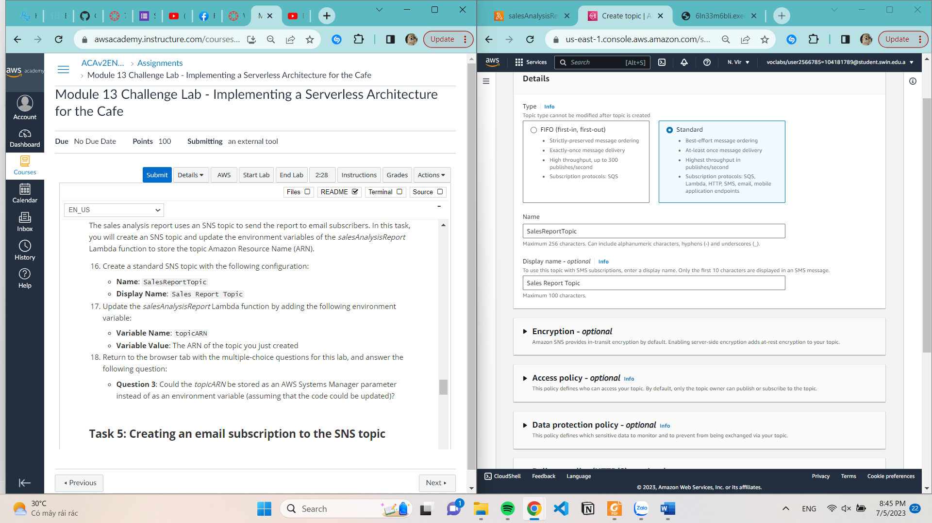

**Update the salesAnalysisReport Lambda function by adding the following environment variable:**

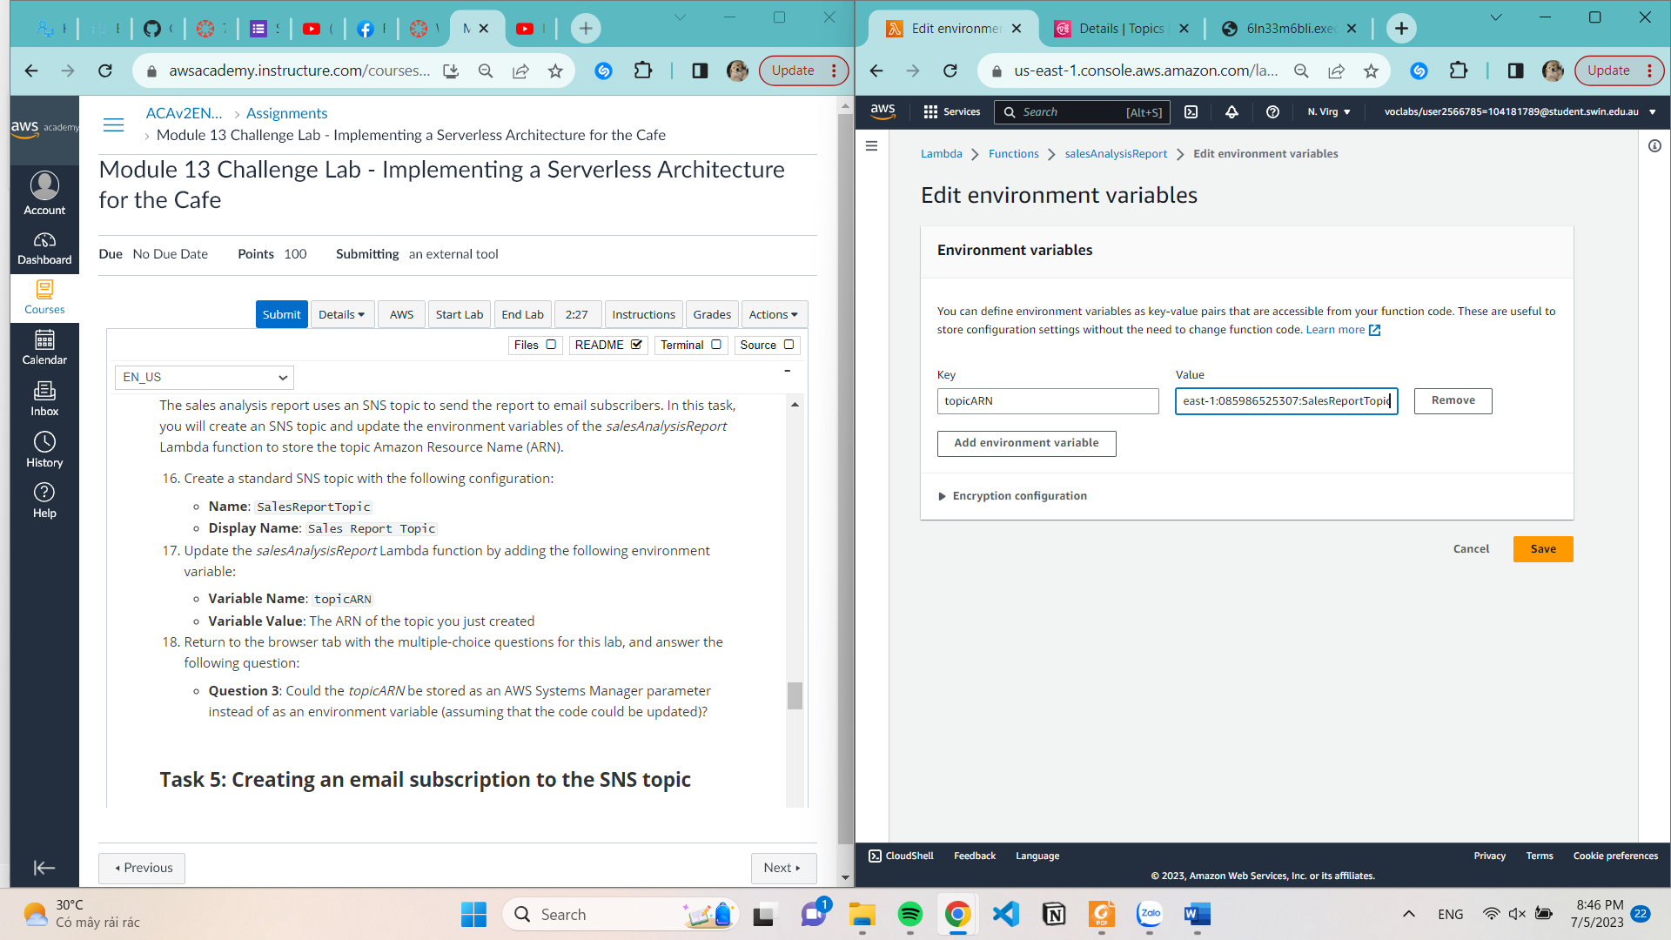

**Task 5: Creating an email subscription to the SNS topic**

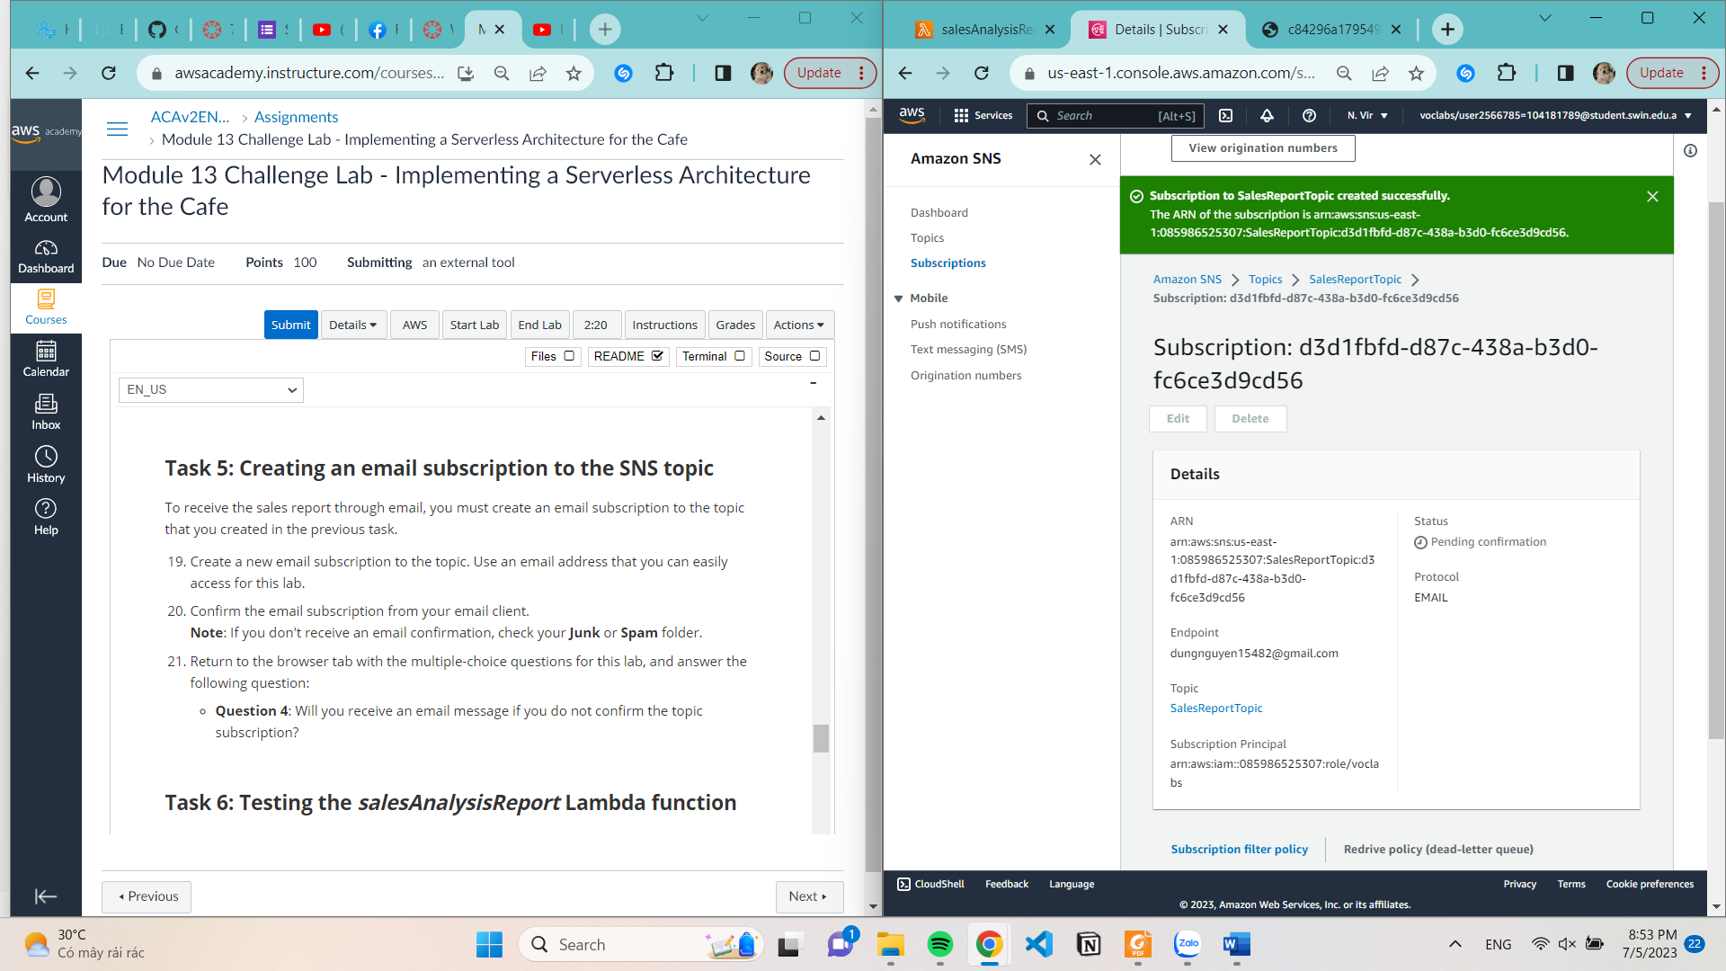

**Task 6: Testing the salesAnalysisReport Lambda function**

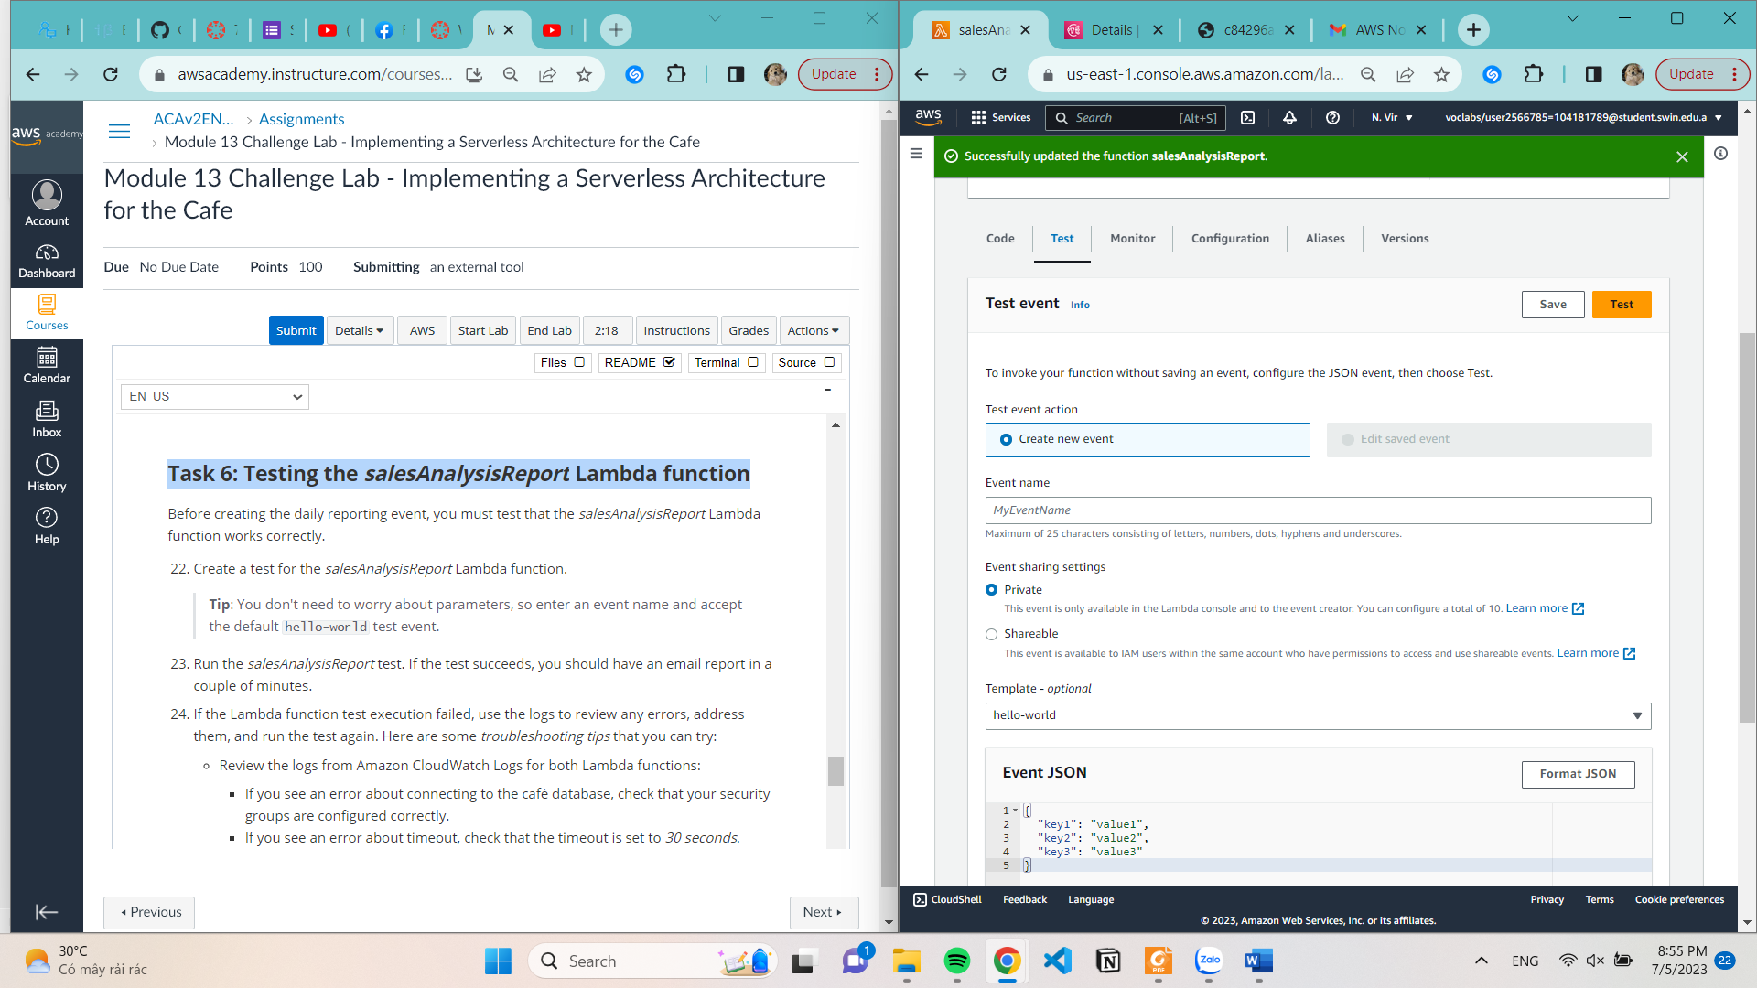

**Succeeded**

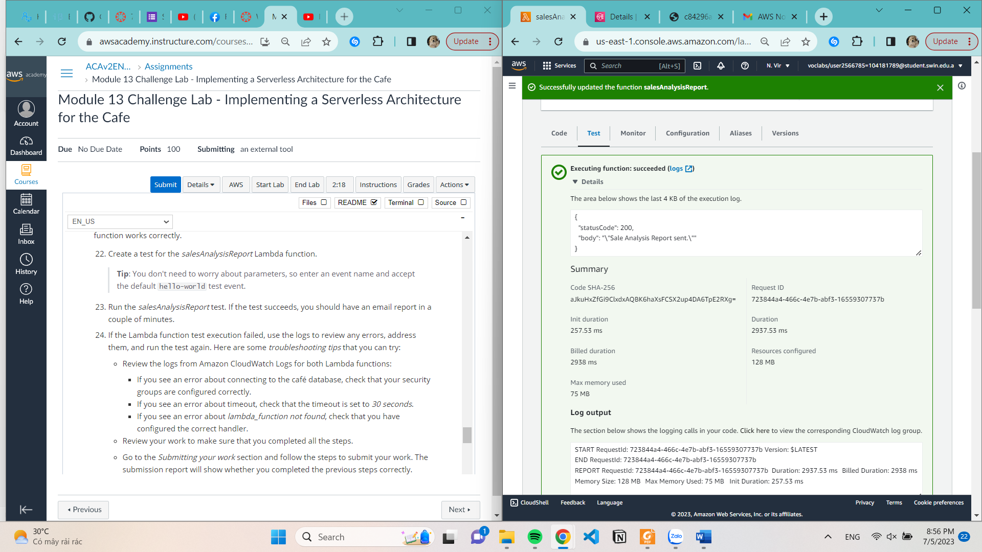

**Task 7: Setting up an Amazon EventBridge event to trigger the Lambda function each day**

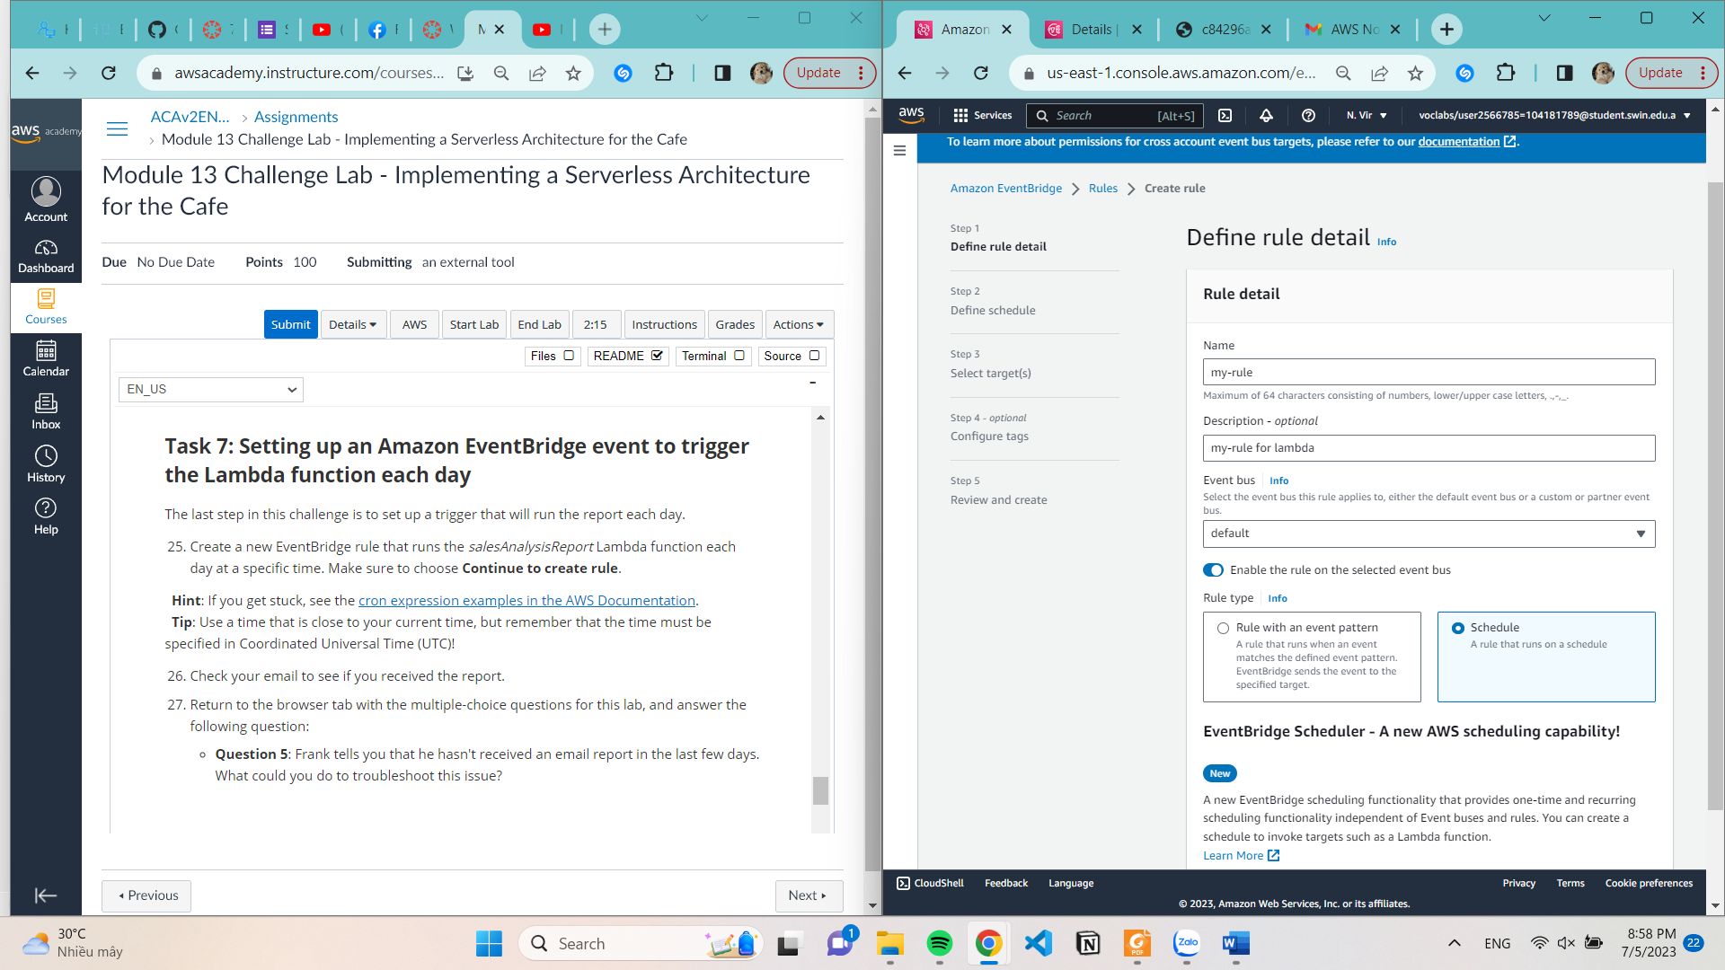

**Select pattern**

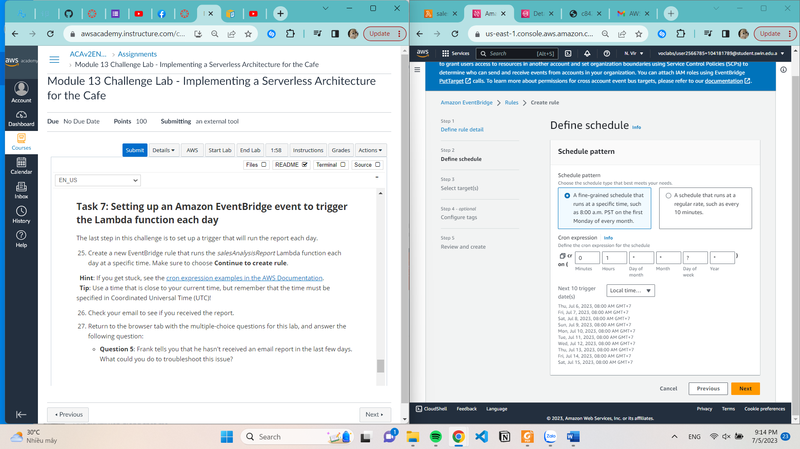

**Select Target**

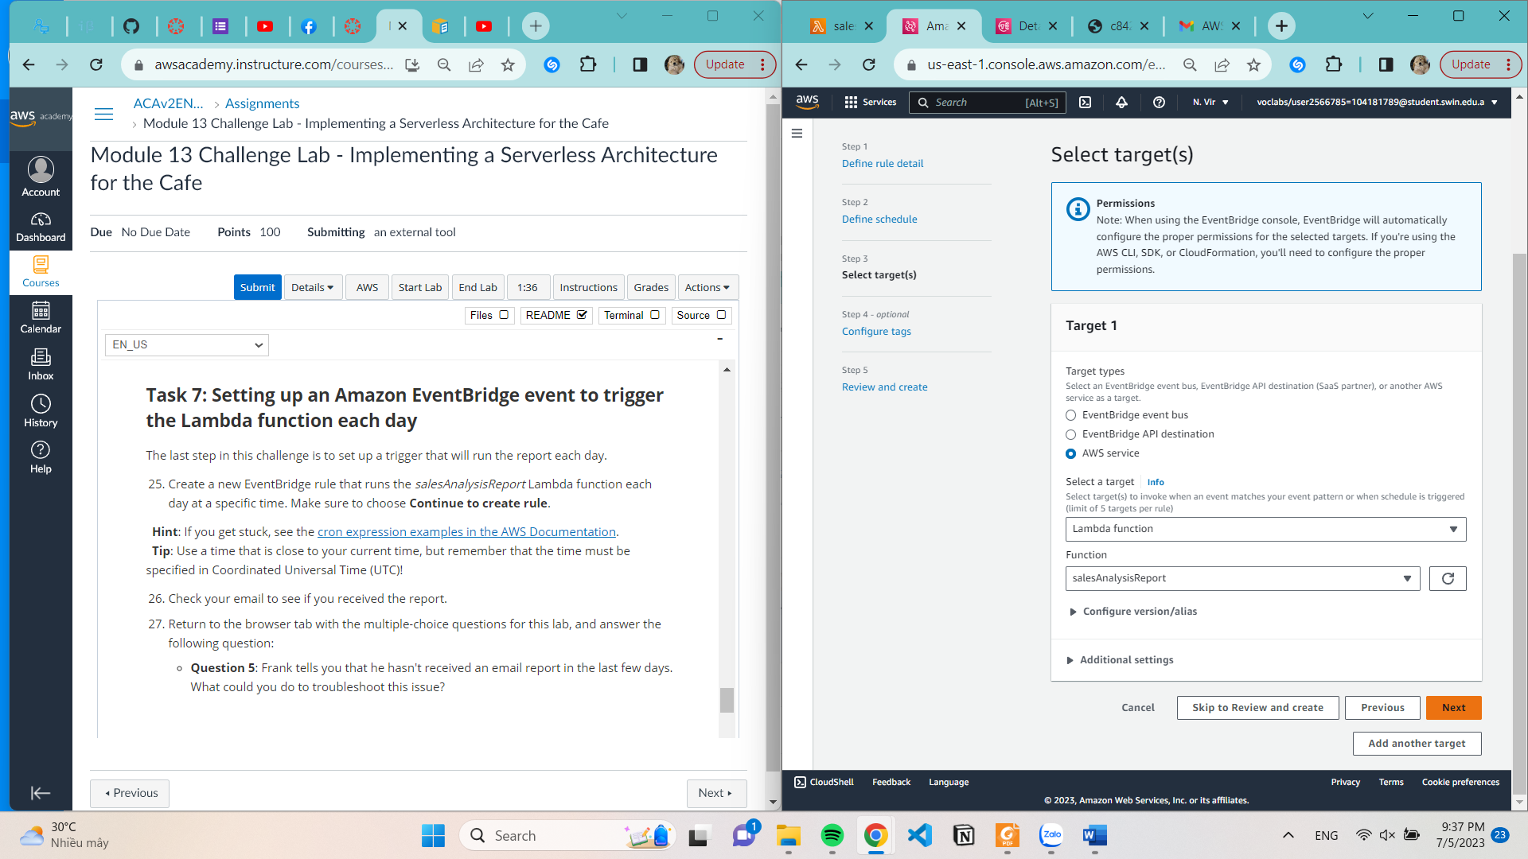

**Succeeded create rule**